**FORMAN CHRISTIAN COLLEGE**

**(A CHARTERED UNIVERSITY)**

**CSCS 495 A**

**FA24**

**TryHackMe**

**Assignment 2 Report**

Daim Bin Khalid – 251686775

Hafsah Shahbaz - 251684784

18th November, 2024

**Introduction**

This task involves setting up a TryHackMe account and configuring a VPN connection using OpenVPN. The VPN allows secure connectivity to TryHackMe's virtual network, enabling hands-on cybersecurity exercises. This report details the steps taken, including account creation, VPN configuration, and connectivity verification.

**1. Creating a TryHackMe Account**

1. Navigate to [TryHackMe](https://tryhackme.com) by searching on Browser in Kali.
2. Click on the "Join For Free" button on the top-right corner.
3. Fill out the required information form with my email address.
4. Verified the email through the confirmation link received.
5. Logged into the TryHackMe portal, landing on the dashboard page.

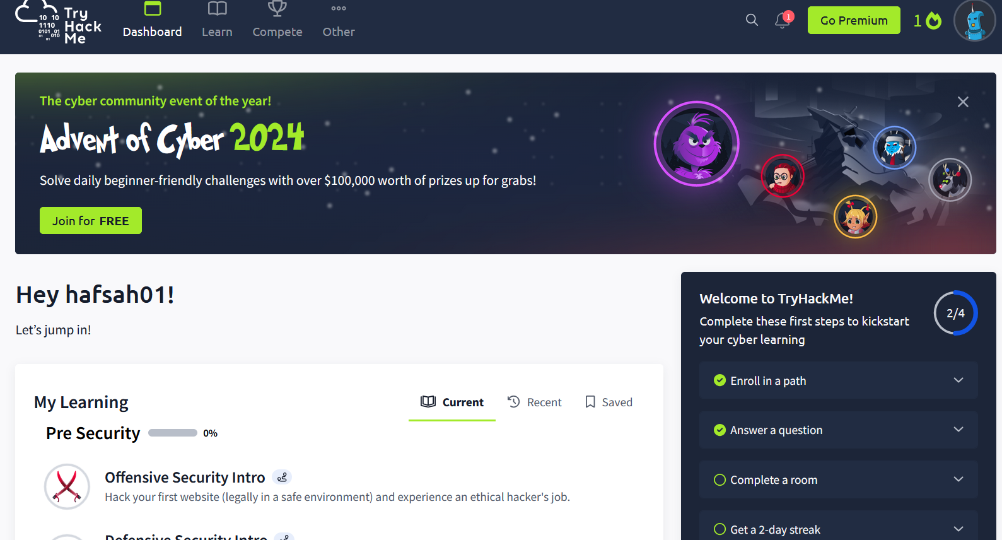

**2. Downloading the Configuration File**

1. Click on the profile icon at the top-right corner of the dashboard and selected **Access**.

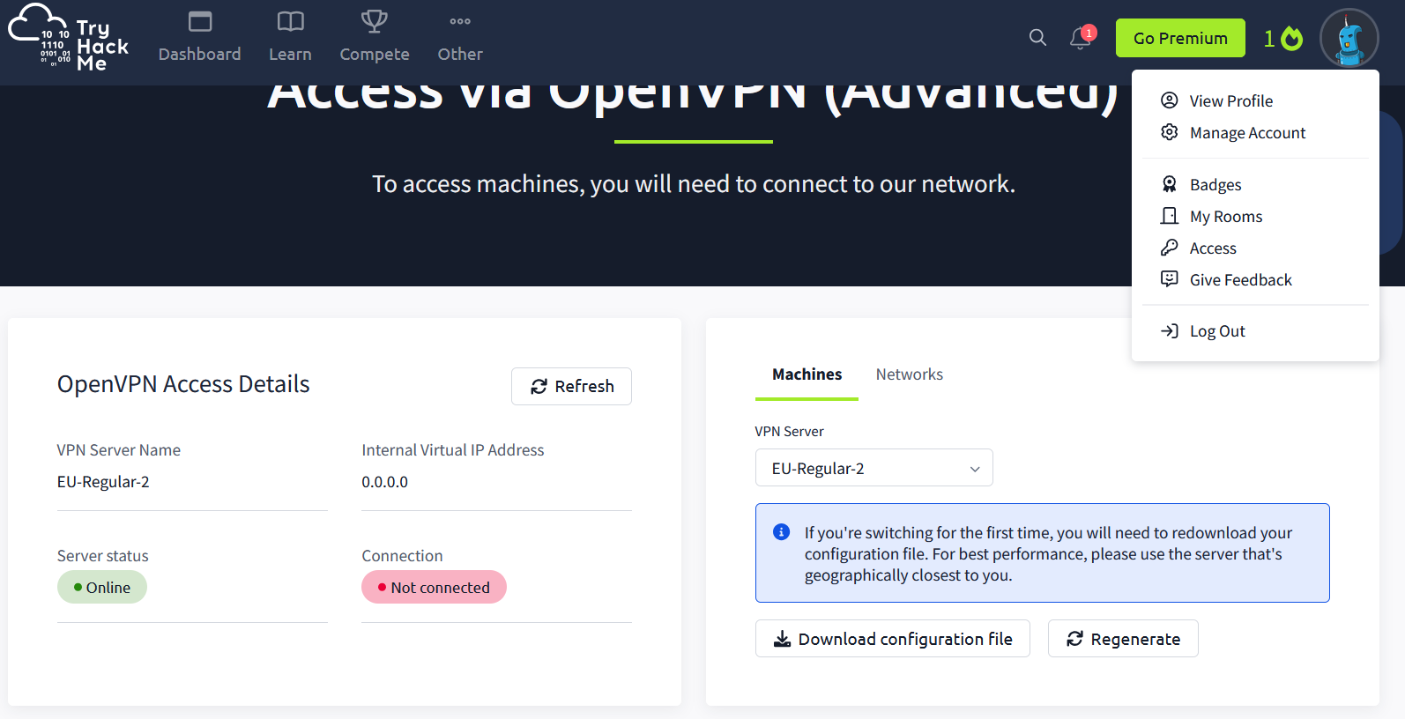

1. Located the option to download the OpenVPN configuration file (.ovpn) and downloaded it.
   * The .ovpn file contains all necessary parameters for establishing the VPN connection.

**3. Configuring OpenVPN**

1. Opened a terminal in Kali Linux.
2. Ensure OpenVPN was enabledA screenshot of a computer program

   Description automatically generated
3. Navigated to the directory where the .ovpn file was saved:

cd ~/Downloads

1. Started OpenVPN with the following command:

sudo openvpn hafsah01ovpn

The process initialized, and the message Initialization Sequence Completed confirmed the VPN connection was established.

**4. Verifying the VPN Connection**

1. Opened a new terminal tab and checked network interfaces:

Ifconfig

Confirmed the creation of the tun0 interface with an assigned IP address, indicating the VPN was active.

1. Returned to the TryHackMe **Access** page and refreshed. Verified:

* **VPN Server Name**
* **Internal Virtual IP Address**
* **Server Status: Online**
* **Connection: Connected**

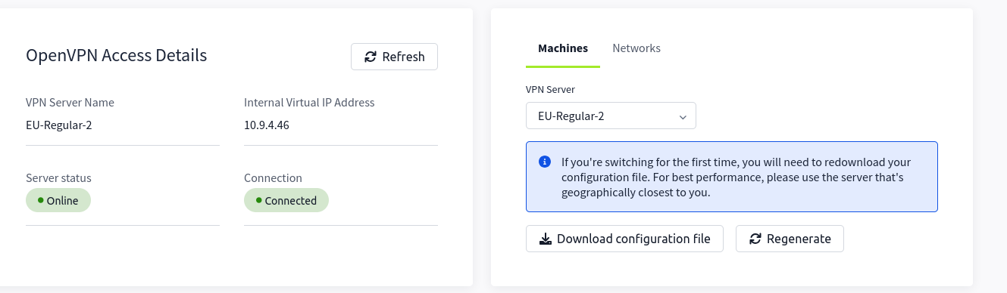

**5. Exploring TryHackMe Linux Room**

1. Navigated to the **Learn** section and searched for "Linux".
2. Selected the first room titled **Linux Fundamentals Part 1**. A screenshot of a computer

   Description automatically generated
3. Completed Task 1 and 2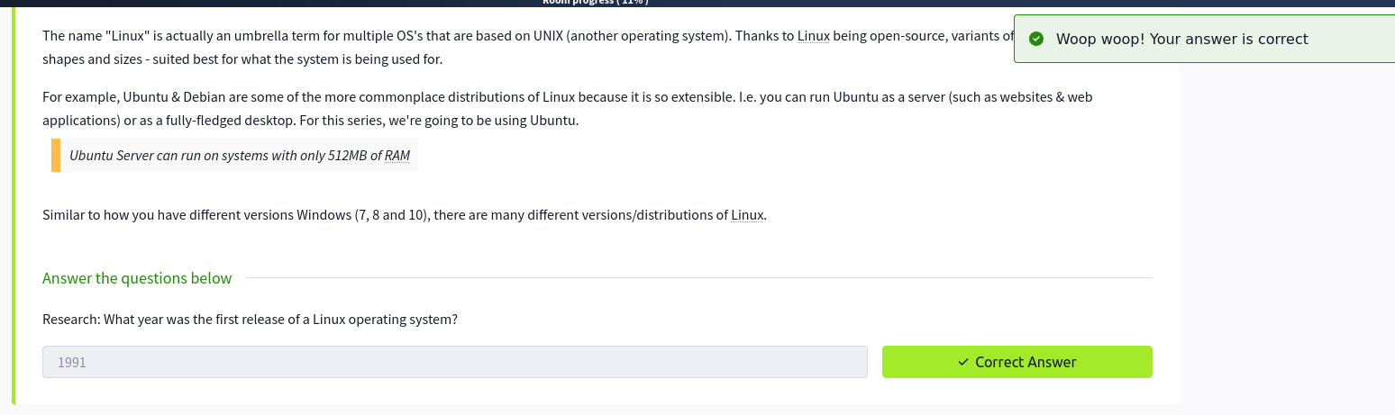
4. Started the machine for Task 3 in the room and verified connectivity with the target IP address.

1. Practiced commands and concepts on the provided Linux terminal.

**Conclusion**

In this task, we successfully set up a TryHackMe account, configured a VPN connection, and verified connectivity. These steps allowed seamless access to TryHackMe’s environment for hands-on exercises. All steps were completed as outlined, with screenshots providing visual confirmation.